Problem + Algorithm
Experiment No.: 10
Title: Simulated Annealing for Function Optimization with User-Defined Parameters
Aim:
Implement Simulated Annealing to minimize a quadratic objective function using user-supplied parameters and display the actual iteration path.
Problem Statement:
Given f(x) = ax² + bx + c, allow the user to enter a, b, c, the initial solution x₀, initial temperature T₀, cooling factor α, and minimum temperature T_min. Use Simulated Annealing to search for a low function value and plot the sequence of accepted states.
Algorithm:
- Read a, b, c, x₀, T₀, α, and T_min from the user.
- Initialize the current solution x = x₀ and evaluate f(x).
- Generate a neighbouring candidate by adding or subtracting the fixed step size of 1.
- Calculate Δ = f(candidate) − f(current).
- Accept the candidate if Δ ≤ 0; otherwise accept it with probability exp(−Δ/T).
- Record the state after the acceptance decision.
- Reduce temperature using T = αT and repeat while T ≥ T_min.
- Display the final result and, when a ≠ 0, calculate the analytical vertex x = −b/(2a).
- Plot the objective function and the chronological path of states.
Program
The code below follows the supplied Simulated_Annealing_User_Input_With_Path notebook. It requests seven values interactively and produces a results table and iteration-path graph.
# USER INPUT
a = float(input('Enter a: '))
b = float(input('Enter b: '))
c = float(input('Enter c: '))
x0 = float(input('Enter x0: '))
T0 = float(input('Enter T0: '))
alpha = float(input('Enter alpha: '))
T_min = float(input('Enter T_min: '))

print('\nParameters entered:')
print(f'a = {a}, b = {b}, c = {c}')
print(f'x0 = {x0}, T0 = {T0}, alpha = {alpha}, T_min = {T_min}')

import math
import random
import numpy as np
import pandas as pd
import matplotlib.pyplot as plt

# Fixed settings — everything other than the seven requested parameters remains fixed
neighbour_step = 1
iterations_per_temperature = 1
seed = 42

def f(x):
return a*x**2 + b*x + c

random.seed(seed)
np.random.seed(seed)

# Simulated Annealing
current_x = x0
current_value = f(current_x)
temperature = T0
history = []
iteration = 0

# Store initial state as iteration 0
history.append({
'Iteration': 0,
'Temperature': temperature,
'Current x': current_x,
'Current f(x)': current_value,
'Candidate x': np.nan,
'Candidate f(x)': np.nan,
'Delta': np.nan,
'Acceptance Probability': np.nan,
'Accepted': True
})
while temperature >= T_min:
for _ in range(iterations_per_temperature):
iteration += 1
candidate_x = current_x + random.choice([-neighbour_step, neighbour_step])
candidate_value = f(candidate_x)
delta = candidate_value - current_value

if delta <= 0:
accepted = True
probability = 1.0
else:
probability = math.exp(-delta / temperature)
accepted = random.random() < probability

# Record the state AFTER the acceptance decision.
if accepted:
current_x = candidate_x
current_value = candidate_value

history.append({
'Iteration': iteration,
'Temperature': temperature,
'Current x': current_x,
'Current f(x)': current_value,
'Candidate x': candidate_x,
'Candidate f(x)': candidate_value,
'Delta': delta,
'Acceptance Probability': probability,
'Accepted': accepted
})

temperature *= alpha

results = pd.DataFrame(history)
print(f'Total iterations: {iteration}')
print(f'Final x: {current_x}')
print(f'Final f(x): {current_value}')
results

# Final result
print('Simulated Annealing Result')
print('--------------------------')
print(f'Best x found = {current_x}')
print(f'Minimum f(x) = {current_value}')

if a != 0:
analytical_x = -b / (2*a)
print(f'Analytical minimum x = {analytical_x}')
print(f'Analytical minimum f(x) = {f(analytical_x)}')

# GRAPH — ACTUAL ITERATION PATH
# Every plotted point is the state AFTER that iteration.

path_x = results['Current x'].to_numpy()
path_y = results['Current f(x)'].to_numpy()

xmin = path_x.min() - 2
xmax = path_x.max() + 2
if a != 0:
analytical_x = -b/(2*a)
xmin = min(xmin, analytical_x - 2)
xmax = max(xmax, analytical_x + 2)

x_values = np.linspace(xmin, xmax, 600)
y_values = f(x_values)

plt.figure(figsize=(12, 7))
plt.plot(x_values, y_values, linewidth=2, label='Objective function f(x)')

# Connect the actual iteration states in chronological order
plt.plot(path_x, path_y, marker='o', markersize=5, linewidth=1.5, label='Iteration path')

# Direction arrows: iteration i -> iteration i+1
for i in range(len(results)-1):
x1, y1 = path_x[i], path_y[i]
x2, y2 = path_x[i+1], path_y[i+1]
if x1 != x2 or y1 != y2:
plt.annotate('', xy=(x2,y2), xytext=(x1,y1),
arrowprops=dict(arrowstyle='->', linewidth=1))

# Initial and final points
plt.scatter(x0, f(x0), s=140, marker='X', label='Initial point')
plt.scatter(current_x, current_value, s=180, marker='*', label='Final point')

# Iteration labels
for i, row in results.iterrows():
plt.annotate(str(int(row['Iteration'])),
(row['Current x'], row['Current f(x)']),
xytext=(5,5), textcoords='offset points', fontsize=8)

plt.xlabel('x')
plt.ylabel('f(x)')
plt.title(f'Simulated Annealing Iteration Path — f(x)={a}x²+({b})x+({c})')
plt.grid(True, alpha=0.3)
plt.legend()
plt.tight_layout()
plt.show()
Output + Analysis
Objective Function: f(x) = ax² + bx + c
Fixed settings: neighbour step = 1; one iteration per temperature level; random seed = 42.
Sample input used for the illustration in this document (the program itself accepts other inputs):
Parameter | Sample Value
a | 1
b | -4
c | 3
Initial solution x₀ | 8
Initial temperature T₀ | 100
Cooling factor α | 0.90
Minimum temperature T_min | 1
Program Execution (sample run):
Result | Value
Total iterations | 44
Final x in this run | 2.0000
Final f(x) in this run | -1.0000
Analytical minimum x = −b/(2a) | 2.0000
Analytical minimum f(x) | -1.0000
Analysis: The analytical minimum for the sample function f(x) = x² − 4x + 3 is at x = 2, where f(x) = −1. Simulated Annealing is stochastic and the final current state from a single run is not guaranteed to equal the analytical minimum. The program records the current state after each acceptance decision; the graph visualizes this path.
Convergence Graph / Iteration Path
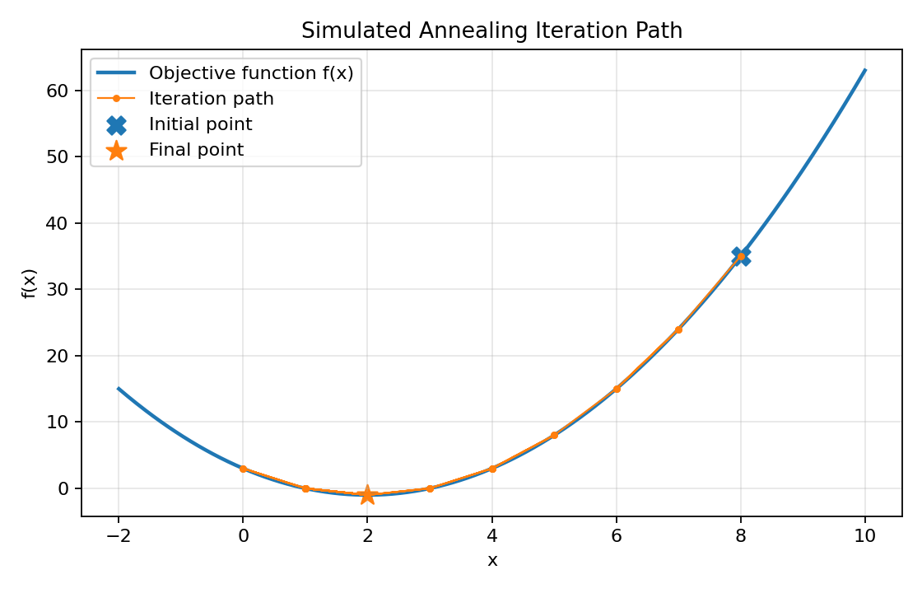
Figure: Objective function and the sequence of states visited during the sample run.
X-axis → x value
Y-axis → f(x); iteration order is shown by the connected path.
Parameter Modification
S. No. | Parameter | Original Value | Modified Value | Observation
1 | Initial temperature T₀ | 100 | 50 | A lower starting temperature reduces the chance of accepting worse moves early in the search.
2 | Cooling factor α | 0.90 | 0.80 | A smaller factor cools the system faster and generally reduces exploration time.
3 | Minimum temperature T_min | 1 | 0.1 | A lower stopping temperature permits more cooling steps and potentially more exploration.
4 | Initial solution x₀ | 8 | 0 | Changing the starting point changes the path taken; results can vary because candidate moves and acceptance are stochastic.

